**Ep:4 A prototype with familiar and unfamiliar navigation elements**

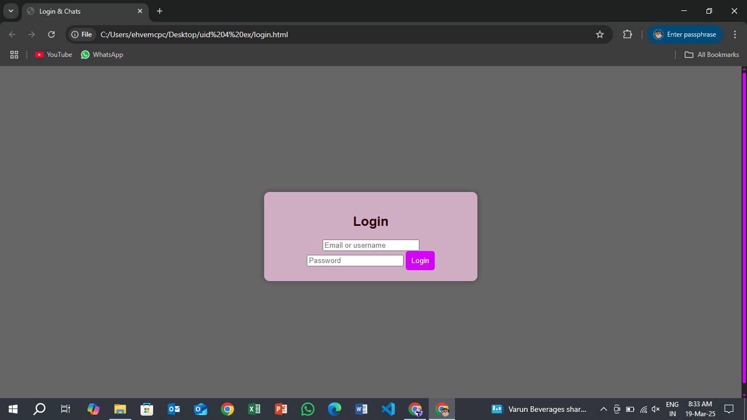

**Familiar UI Elements:** These are design components that users recognize and understand based on prior experience. They improve usability by reducing the learning curve.

• **Login Button:** Recognized as the standard action for accessing accounts.

• **Home Icon:** Universally used to navigate back to the homepage.

.

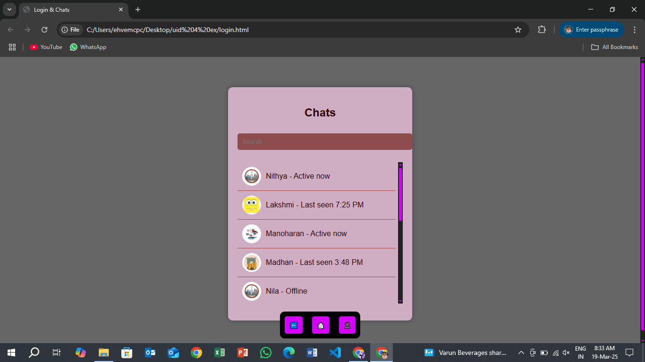

• **Unfamiliar UI Elements:** These are new or unique design choices that may not be immediately intuitive to users While they can enhance innovation, they might require onboarding or tooltips to ensure usability.

**Infinite Loop Scrolling :-** Content continuously scrolls in a loop without a clear start or end.

In this Login page the scroll button is unfamiliar UI element.

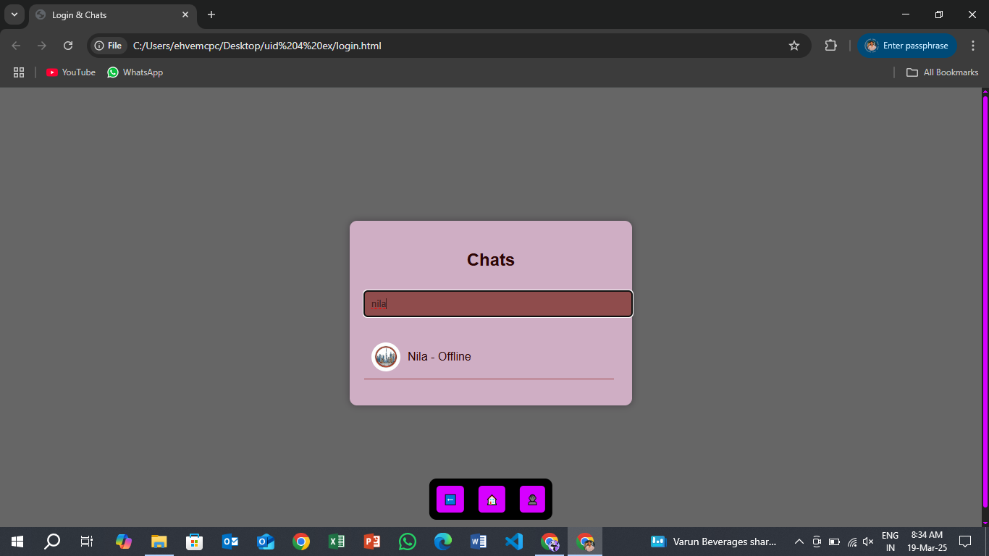

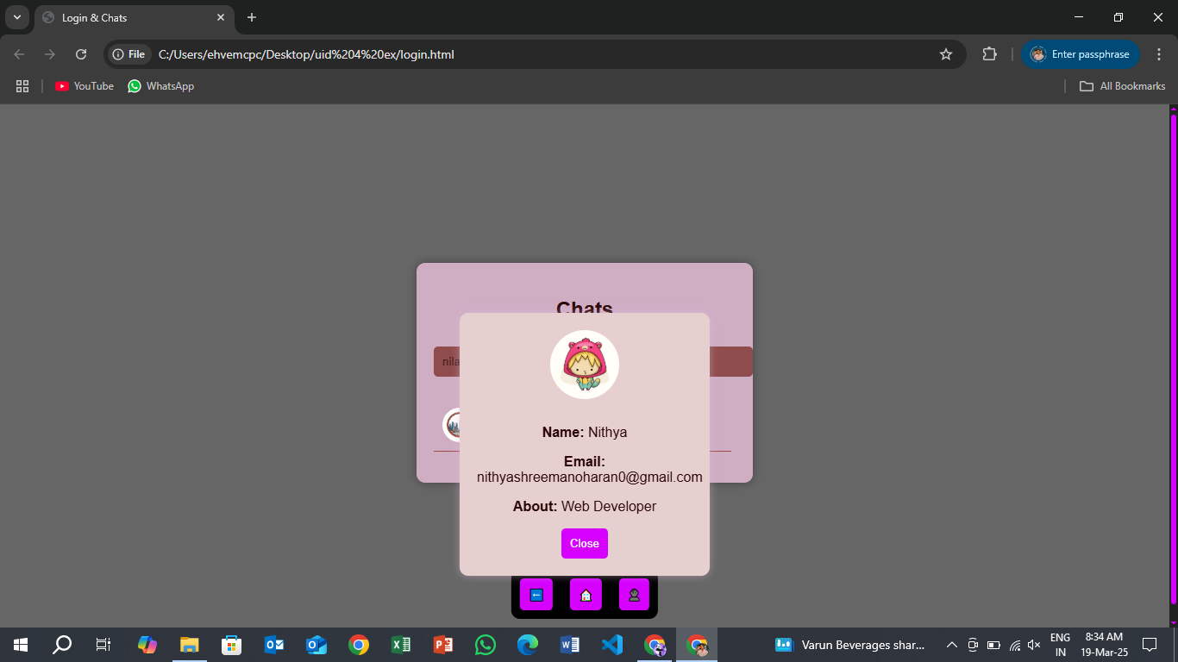

• **Profile Icon:** Represents user accounts or settings, making it easy to find personal information.